1. What is the GPT?

* The General PWM Timer (GPT) is a 32-bit timer with six GPT32 channels, four GPT32E channels, and four GPT32EH channels.
* The PWM waveforms can be generated by controlling the up-counter, down counter, or up-and down-counter.
* GPT can also be used as a General Purpose Timer.
* Basically, GPT can be used to:
  + Count Events (Counter)
  + Measure external input signals (Input Capture)
  + Generate a periodic interrupt (Periodic)
  + Output a periodic (Output Compare)
  + Output a PWM signals (PWM)

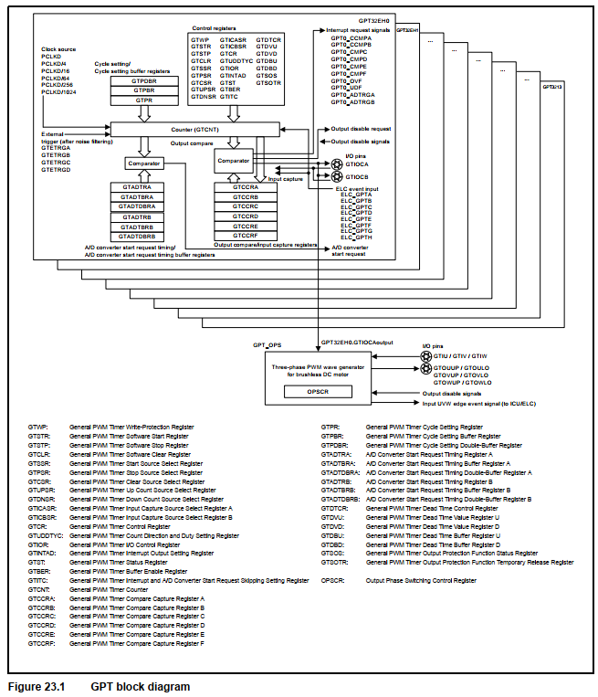

1. What is the Clock Sources of GPT?





* Notice that the Clock supplies for GPT is always PCLKD. And the PCLKD has the ratio with PCLKA:
  + 
* So what is HOCO, MOCO, LOCO, Main clock oscillator (MOSC), Sub-clock oscillator (SOSC), PLL:

1. GPT Modes:

The GPT mode is configured by setting an appropriate value in the MD bits in GPCRn register (n = 0 to 13)

1. GPT memory map

